import matplotlib.pyplot as plt

apps = ['Zomato', 'Swiggy', 'Uber Eats', 'Dunzo', "Domino's"]
orders = [1200, 1100, 700, 500, 800]

colors = ['red', 'orange', 'blue', 'green', 'purple']

plt.bar(apps, orders, color=colors)

plt.xlabel("Food Delivery Apps")
plt.ylabel("Daily Orders")
plt.title("Daily Orders by Food Delivery Apps")

plt.show()
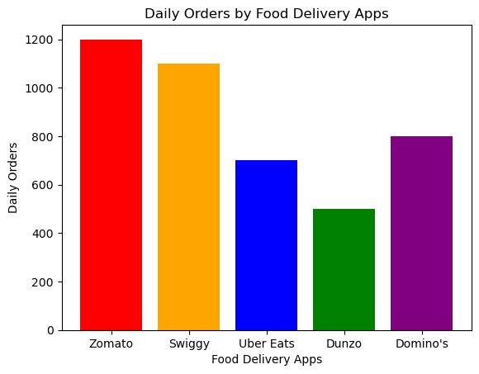
import matplotlib.pyplot as plt

influencers = [
'Influencer A',
'Influencer B',
'Influencer C',
'Influencer D',
'Influencer E',
'Influencer F'
]

followers = [12, 18, 25, 10, 30, 15]

plt.barh(influencers, followers)

plt.xlabel("Followers (in millions)")
plt.ylabel("Influencers")
plt.title("Instagram Influencers by Followers")

plt.show()
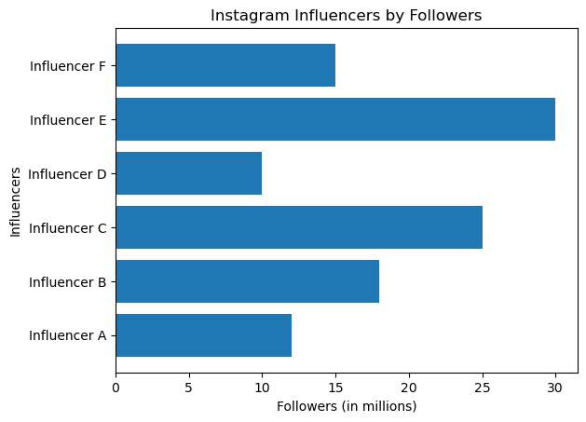
import matplotlib.pyplot as plt

apps = ['Zomato', 'Swiggy', 'Uber Eats', 'Dunzo', "Domino's"]
orders = [1200, 1100, 700, 500, 800]

colors = ['red', 'orange', 'blue', 'green', 'purple']

bars = plt.bar(apps, orders, color=colors)

for bar in bars:
height = bar.get_height()
plt.text(
bar.get_x() + bar.get_width() / 2,
height,
str(height),
ha='center',
va='bottom'
)

plt.xlabel("Food Delivery Apps")
plt.ylabel("Daily Orders")
plt.title("Daily Orders by Food Delivery Apps")

plt.show()
